The Happy Popcorn Popper
The One of a Kind Game Now Available on the Google Play Store!
A game where you pop different popcorn while facing increasingly difficult challenges
United States – July 2016 – Now available, the game The Happy Popcorn Popper offers a fun and exciting game for Android users. Great for friends and family, as well as the solo player, this game offers a variety of popcorn that the user pops to increase their score. The difficulty of the game increases with each level and there are a variety of challenges and plethora of new content to be faced so the player never becomes bored.
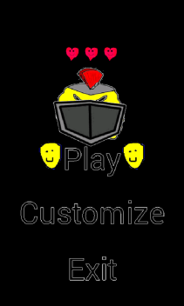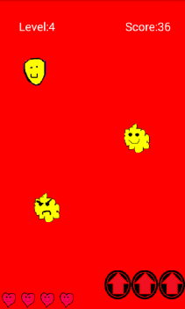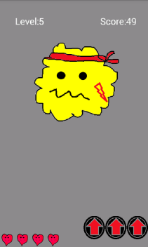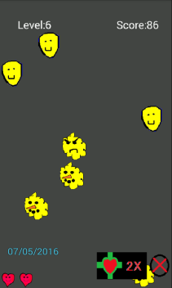
This game involves a variety of features for the player to immerse themselves in. There is a variety of popcorn that the user can pop. There are happy popcorn that increases the score, mad popcorn that takes away one of five lives, and multicolored popcorn that count as 5 points (and there are more popcorn types on the way). With the addition of different bosses that are encountered, the user will not be bored. If the player becomes tired of the popcorn’s look, they can customize the popcorn’s look, choosing from an assortment of popcorn looks. There are also various power ups that the user can combine and try to increase their score! There will also always be new content to provide in future versions!
The Happy Popcorn Popper is available for free and is available world-wide, with language support being added in new versions. Other apps are under construction following this popcorn theme.
Please visit happypopcornpopper.wix.com/happy-popcorn-popper for more information.
The Happy Popcorn Popper is developed by PopcornPopper123, an independent mobile app developer.
###
If you would like more information about The Happy Popcorn Popper, please visit the website or contact at:
Email: happypopcornpoppercreator@gmail.com Facebook: facebook.com/HappyPopcornPopper
To download the app: https://play.google.com/store/apps/details?id=com.ashmore.happyhappypopcornpopper

